Practical 7
Using Temperature & Humidity Sensor
with Raspberry Pi

To interface a DHT11 Temperature & Humidity Sensor with Raspberry Pi 3 and display the temperature and humidity values using Python.

Theory about Temperature & Humidity sensor DHT11

Components Required
- Raspberry Pi 3
- DHT11 Temperature & Humidity Sensor (module preferred)
- Jumper wires (Male–Female)
- Breadboard (optional)
- Micro-SD card with Raspberry Pi OS
- Internet connection (for library installation)

Pin connections

DHT11 Pins | Raspberry Pi Pins | GPIO Numbering
VCC (+) | Pin 1 | 3.3V
Data (Out) | Pin 7 | GPIO4
GND (-) | Pin 6 | Ground

| DHT11 Pins | Raspberry Pi Pins | GPIO Numbering |
|-------------|-------------------|----------------|
| VCC (+) | Pin 1 | 3.3V |
| Data (Out) | Pin 7 | GPIO 4 |
| GND (-) | Pin 6 | Ground |

Install Required Libraries
Directly install the libray using Thonny > Manage Packages > Search for Adafruit_DHT > Install
- sudo apt install python3-pip (if already installed need not install again)
- pip3 install Adafruit_DHT

Digital Temperature and Humidity Sensor
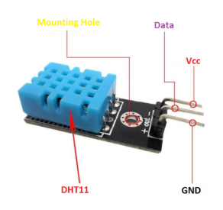
Version :- DHT11
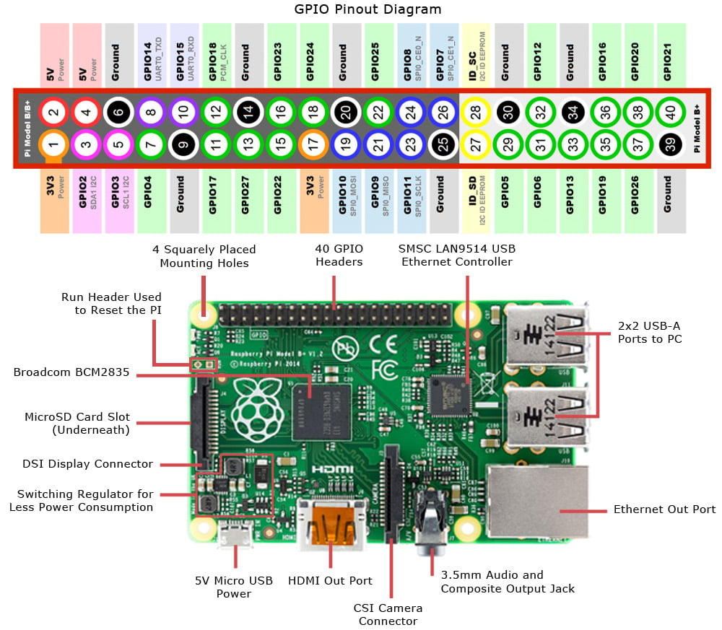
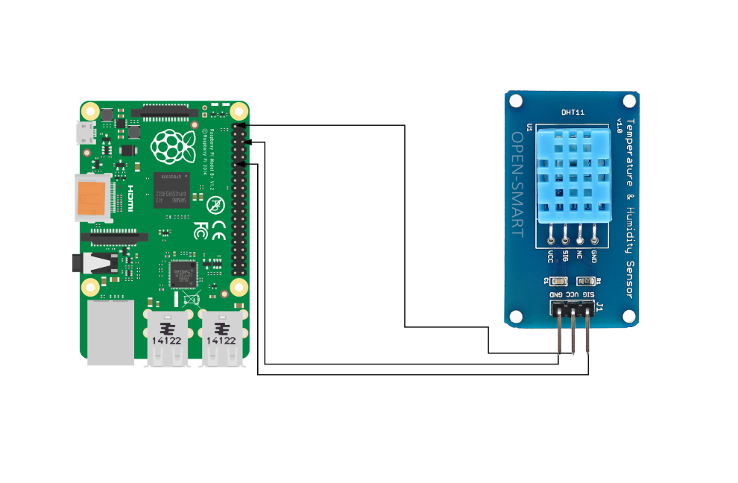
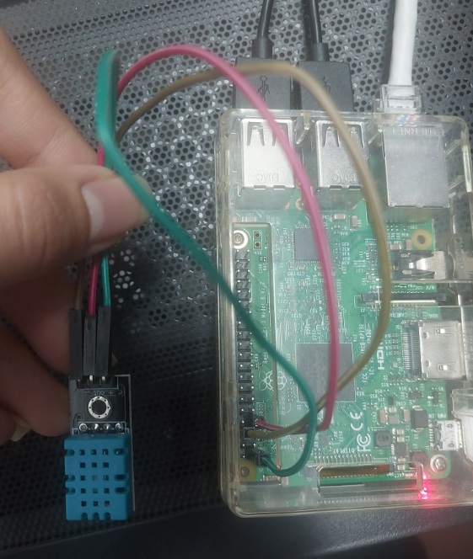
Code: -
'''
To interface a DHT11 Temperature & Humidity Sensor with Raspberry Pi 3
and display the temperature and humidity values using Python.
'''

import Adafruit_DHT
import time

# Sensor type
sensor = Adafruit_DHT.DHT11

# GPIO pin where DATA is connected
gpio_pin = 4

while True:
humidity, temperature = Adafruit_DHT.read(sensor, gpio_pin)

if humidity is not None and temperature is not None:
print("Temperature = {:.1f}°C".format(temperature))
print("Humidity = {:.1f}%".format(humidity))
print("------------------------------")
else:
print("Failed to retrieve data from sensor")

time.sleep(2)

Output: -
